ADDITIONAL QUERRIES-DBMS LAB 5

-- List employees with their department name & location

SELECT E.ENAME,D.DLOC,D.DNAME
FROM EMPLOYEE E, DEPT D
WHERE (E.DEPTNO=D.DEPTNO);
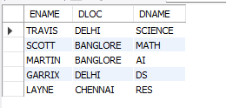
-- Employees who are not assigned to any project ,Project-wise headcount

SELECT E.ENAME
FROM EMPLOYEE E
WHERE E.EMPNO NOT IN (SELECT E.EMPNO FROM EMPLOYEE E,ASSIGNED_TO A WHERE E.EMPNO=A.EMPNO);


SELECT P.PNO,P.PNAME,COUNT(A.EMPNO) AS HEADCOUNT
FROM PROJECT P,ASSIGNED_TO A
WHERE P.PNO=A.PNO
GROUP BY P.PNO,P.PNAME;
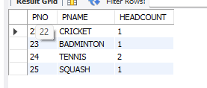

-- Department-wise average & max salary

SELECT D.DNAME,AVG(E.SAL) AS "AVERAGE",MAX(E.SAL) AS "MAX"
FROM EMPLOYEE E, DEPT D
WHERE E.DEPTNO=D.DEPTNO
GROUP BY D.DNAME;
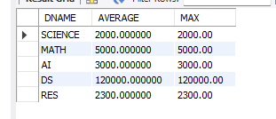
-- Total incentives earned by each employee (lifetime)

SELECT E.ENAME,SUM(I.INCENTIVE_AMOUNT) AS "TOTAL INCENTIVES"
FROM EMPLOYEE E,INCENTIVES I
WHERE E.EMPNO=I.EMPNO
GROUP BY E.EMPNO;
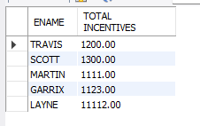
-- Employees working on a given project (project name :Alpha Project)

SELECT E.ENAME,P.PNAME
FROM EMPLOYEE E,ASSIGNED_TO A, PROJECT P
WHERE E.EMPNO=A.EMPNO AND A.PNO=P.PNO AND P.PNAME="CRICKET";
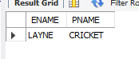

-- Departments with no employees

SELECT D.DNAME
FROM DEPT D, EMPLOYEE E
WHERE E.DEPTNO=D.DEPTNO
GROUP BY D.DEPTNO
HAVING COUNT(E.EMPNO)<1;
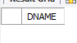

-- Managers and their direct report counts (MGR_NO references EMPNO)

SELECT E.MGR_NO,COUNT(E.EMPNO)
FROM EMPLOYEE E, ASSIGNED_TO A
WHERE E.EMPNO=A.EMPNO
GROUP BY E.MGR_NO;
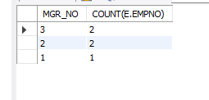

-- Employees assigned to more than one project
SELECT E.ENAME
FROM EMPLOYEE E, ASSIGNED_TO A
WHERE E.EMPNO=A.EMPNO
GROUP BY A.EMPNO
HAVING COUNT(A.PNO)>1;
